Project: Election System (OOT Project)

Modules Covered:
- Main Menu
- Admin Login
- Debug Mode

🔹 1. EQUIVALENCE PARTITIONING (EP)

1.1 Main Menu

Test Case ID | Input | Partition Type | Expected Output
MM_EP_01 | 1–12 (valid options) | Valid | Navigate to selected module
MM_EP_02 | 0 | Invalid | Show error message
MM_EP_03 | 13+ | Invalid | Show error message
MM_EP_04 | String ("abc") | Invalid | Show error message

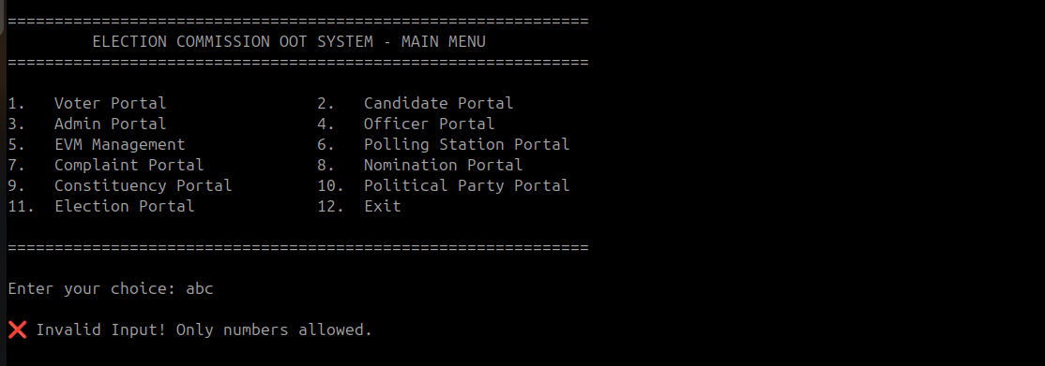

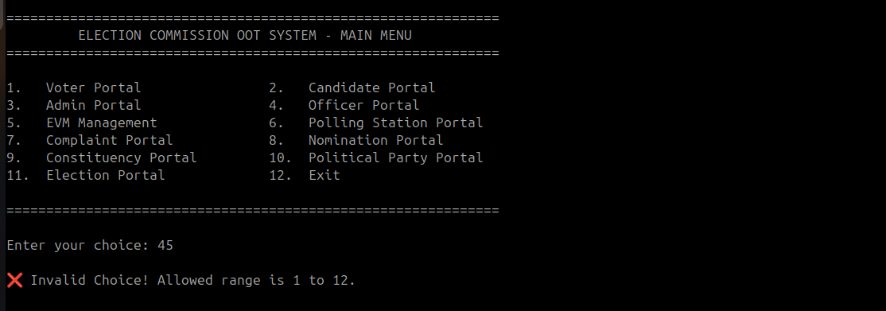

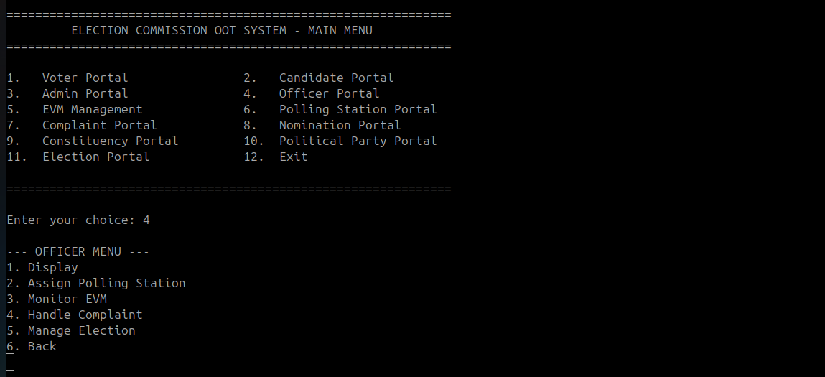

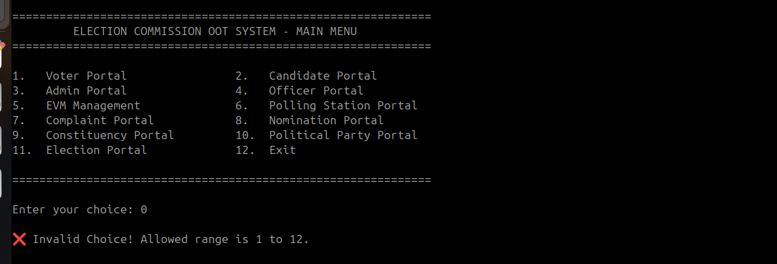

1.2 Admin Login

Test Case ID | Input | Partition Type | Expected Output
AL_EP_01 | Correct username & password | Valid | Login successful
AL_EP_02 | Wrong username | Invalid | Login failed
AL_EP_03 | Wrong password | Invalid | Login failed
AL_EP_04 | Empty fields | Invalid | Prompt required fields
AL_EP_05 | Special characters in username | Invalid | Error message

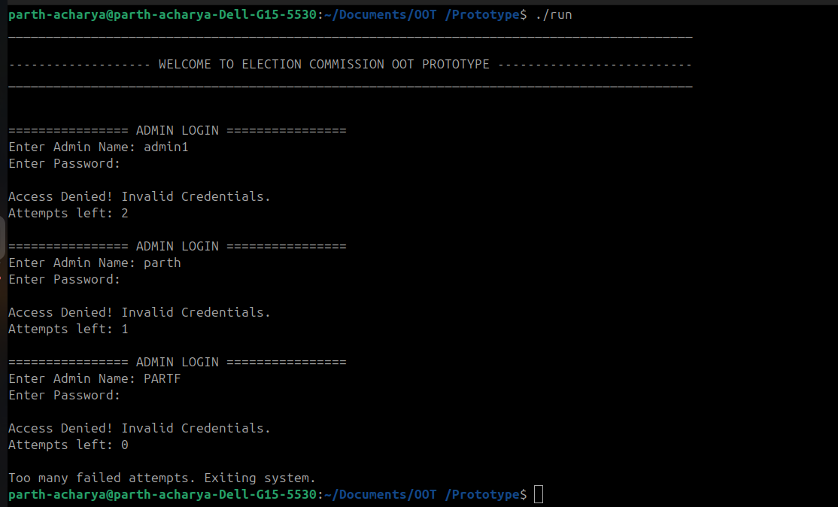

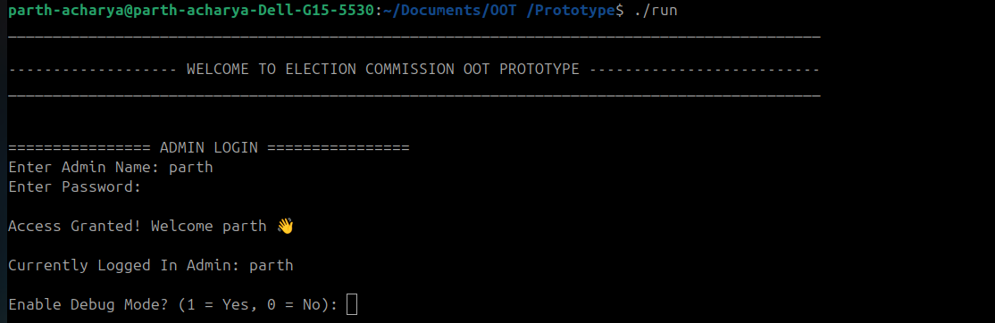

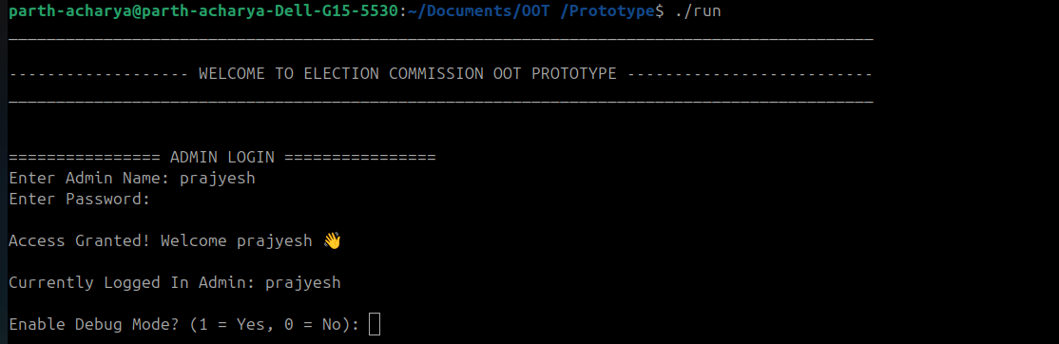

1.3 Debug Mode

Test Case ID | Input | Partition Type | Expected Output
DM_EP_01 | Valid debug command | Valid | Execute debug
DM_EP_02 | Invalid command | Invalid | Show error
DM_EP_03 | Empty input | Invalid | Prompt input
DM_EP_04 | Numeric input instead of command | Invalid | Error

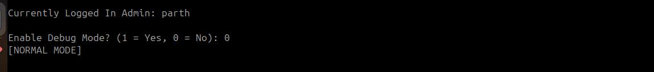

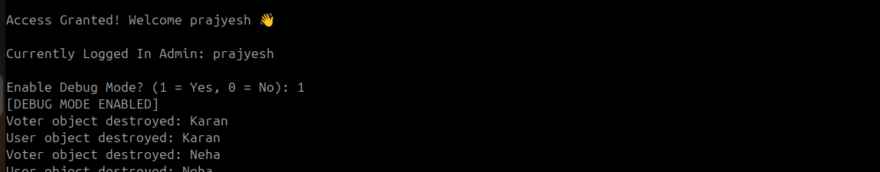

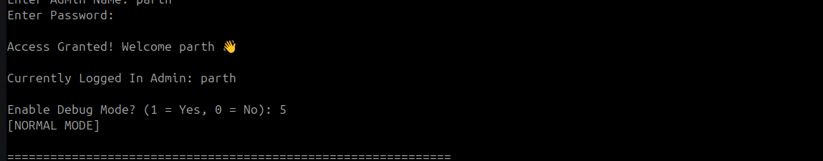

🔹 2. BOUNDARY VALUE ANALYSIS (BVA)

2.1 Main Menu

Test Case ID | Input | Boundary Type | Expected Output
MM_BVA_01 | 1 | Lower boundary | Valid selection
MM_BVA_02 | 12 | Upper boundary | Valid selection
MM_BVA_03 | 0 | Just below lower | Error
MM_BVA_04 | 13 | Just above upper | Error
MM_BVA_05 | 2–11 | Normal | Valid

2.2 Admin Login (Password length example: 6–12)

Test Case ID | Input | Boundary Type | Expected Output
AL_BVA_01 | 6 chars | Min valid | Accept
AL_BVA_02 | 12 chars | Max valid | Accept
AL_BVA_03 | 5 chars | Below min | Reject
AL_BVA_04 | 13 chars | Above max | Reject

2.3 Debug Mode

Test Case ID | Input Length | Boundary Type | Expected Output
DM_BVA_01 | 1 char | Min | Accept/Process
DM_BVA_02 | Max allowed | Max | Accept
DM_BVA_03 | Empty | Below min | Error

🔹 3. DECISION TABLE TESTING

3.1 Admin Login
Conditions | Case 1 | Case 2 | Case 3 | Case 4
Correct Username | Y | Y | N | N
Correct Password | Y | N | Y | N
Action | Login Success | Error | Error | Error

3.2 Main Menu
Conditions | Case 1 | Case 2 | Case 3
Input valid (1–12) | Y | N | N
Input numeric | Y | Y | N
Action | Navigate | Error | Error

3.3 Debug Mode
Conditions | Case 1 | Case 2 | Case 3
Valid command | Y | N | N
Input empty | N | Y | N
Input invalid | N | N | Y
Action | Execute | Prompt | Error

🔹 4. ERROR GUESSING
(Based on experience & common bugs)

4.1 Main Menu
Test Case ID | Scenario | Expected Output
MM_EG_01 | Infinite loop on wrong input | Program should not hang
MM_EG_02 | Enter float (2.5) | Reject input
MM_EG_03 | Press Enter only | Ask for input again

4.2 Admin Login
Test Case ID | Scenario | Expected Output
AL_EG_01 | SQL injection-like input | Reject input
AL_EG_02 | Very long input | Handle safely
AL_EG_03 | Case sensitivity issue | Validate properly

4.3 Debug Mode
Test Case ID | Scenario | Expected Output
DM_EG_01 | Unknown command | Error
DM_EG_02 | Repeated commands | Stable execution
DM_EG_03 | Invalid sequence | Proper handling

